Buckden Local History Society

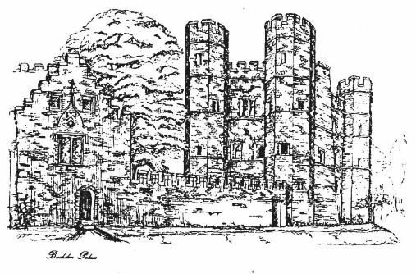

Programme
2021-2022

Meetings are held at
Millard Suite
Village Hall
at 7.30pm
on
the first Wednesday of the month

September 1 - 2021
Buckden Archaeology by Barry Jobling
Barry will update on the archaeological work and the plans for an exhibition.

October 6
The Battle of the Atlantic by Mark Bunting
The Battle of the Atlantic - WWII's Longest Battle. Churchill said of the Battle of the Atlantic 'The only thing that ever really frightened me during the war was the U-boat peril.' Mark Bunting examines how the Allies defeated the 'U-boat peril' and won the Battle of the Atlantic.

November 3
The History of Papworth Hospital 1918 – 2018 by Becky Proctor
Becky will cover the early experiment for tuberculosis patients in the village of Bourn to the move to Papworth Hall in 1918, and the later development of Papworth Village Settlement, the creation of Papworth Hospital, and currently with the move to the new site on the Cambridge Biomedical Campus in May 2019.

December 1
The Trial of Charles 1st by John Davies
Following on from the success of the trial Charles by the Sealed Knot Society, John talks about the main events and how it was recreated

Annual Subscription £16.00
Visitor Fees £4.00
Chairman: Barry Jobling
Vice Chairman: Clive Thompson
Chairman: Barry Jobling
Treasurer: Eric Nash
Secretary: Richard Storey
Committee Members:
Les Button
Fiona Shirley
Founded in 1979, the Society aims to promote the study and knowledge of local history in its very widest sense, primarily by means of talks on all manner of topics in any way connected with the subject and will be pleased to promote individual or group research into local history projects.
Anyone interested in research is asked to contact
The Chairman: blhschairman@btinternet.com
Buckden Local History Society is affiliated to the Cambridgeshire Association for Local History.
For more information the Society can be contacted by email at
Buckdenhistory@gmail.com

January/February Cancelled

March 2
Grafham Water by Richard Storey
Richard will use Robin Gibson's presentation from 2016 with updated information

April 6
Kill or Cure: Dr T. J. Walker, Victorian Surgeon by Liz Davies
The Curator of the St Neots Museum uses the personal diary of Dr Thomas James Walker, the surgeon at Peterborough Infirmary in the 1860s, to examine the life of a Victorian GP and changes in medicine in mid Victorian England.

May 4
Travels with my Great Grandmother by Rita Bates
Rita Bates reads from the diary of her great grandmother who emigrated to Australia in 1900

June 1 AGM and Talk

