Buckden Local History Society

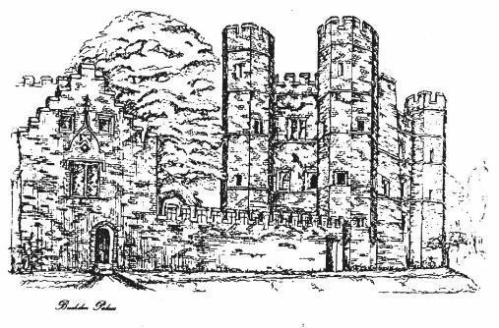

Programme
2022-2023

Meetings are held at
Millard Suite
Village Hall
at 7.30pm
on
the first Wednesday of the month

September 7 - 2022
Renovation of Buckden Towers Gatehouse by Keith Lawrence

Keith talks about the recent renovation to the outer Gatehouse, part of our most iconic village structure, the Towers.

October 5
Religion in 18th Century Huntingdonshire by Simon Clemmow
By analysing 18th-century Church of England visitation returns, Simon explains whether the C of E’s pastoral provision was meeting the population’s needs at that time and how people responded, revealing interesting patterns of Anglicanism and nonconformity.

November 2
Life, Death and Magic in Cambridgeshire: Stories from the Later Prehistoric and Roman Artefacts found on the A14 Cambridge to Huntingdon excavations by Owen Humphreys
Owen, from the Museum of London Archaeology (MOLA) will talk about the A14 finds and outline MOLA’s plans for specialist archaeological workshops.

December 7
A Victorian Family Christmas in Peterborough. by Liz Davies
We revisit the fascinating diary of local Peterborough surgeon and GP, Dr T. J. Walker, who lived in the city from the 1860s. From Christmas trees to pantomimes and services at the Cathedral, Liz describes how the Walker family and other local people celebrated Christmas during this period. Warning - this talk includes lots of corny Victorian jokes!

January 4 2023
What's glorious about a revolution? by Linda Upham

Linda looks at the power politics struggle of the late 17th century and how we lost a king and gained a parliament, culminating with William of Orange.

Chairman: Richard Storey
Vice Chairman: Clive Thompson
Treasurer: Eric Nash
Secretary: Richard Storey
Committee Members:
Barry Jobling
Nicky Gibbs
Les Button
Fiona Shirley

Buckden Local History Society is affiliated to the Cambridgeshire Association for Local History.
For more information on the Society please see https://www.buckdenhistory.co.uk/
or contact the Secretary at
Buckdenhistory@gmail.com

February 1
Recreation of the Witch Trial at Huntingdon Town Hall by John Davies

In Huntingdon 1646 a number of men and women were arraigned for trial accused of witchcraft. John talks about this event, the “Witchfinders” Matthew Hopkins and John Stearn, and the Museum’s historical reenactment in November 2022.

March 1
The Greens of Conyeygarth, Buckden by John Upham
John talks about the Green family and of course about our famous VC recipient.

April 5
The Impact of the Industrial Revolution on our towns and villages by Grace Richards
The industrial revolution and the growth of cities dramatically changed Britain, and helped create modern society as we know it. Grace describes what it was like for families living in big cities and the impact on communities in towns and villages like St Neots and Buckden, and the lessons we can take going into the future.

May 3
Ramsey Abbey Archaeology Project by Roger Mould
Using Lottery funding, the Ramsey project, with the help of Oxford Archaeology East, excavated the scheduled monument of Ramsey Abbey. Roger describes the nationally important results that were discovered.

June 7
AGM and The R101 Disaster by Terry Hayward
Was the R101 disaster an unfortunate accident or avoidable political catastrophe? Terry describes the events that led up to the disaster on its voyage to India on 4 October 1930, from Cardington, near Bedford.

